L23: Preparation Assignment Worked Solutions 221B&C
Part I: Concepts Answer the following questions as you read Lesson 23 in the Online Textbook.
- What are the five assumptions to check in order to do inference for simple linear regression? How do we check for them? Answer these questions by filling in the following chart:
Assumption | How you Check | What you hope to see
There is a linear relationship between X and Y. | Make a scatterplot and check visually for a linear relationship. Then make a residual plot as well. | A hot dog/cucumber shape in the data.  There should be no pattern in the residuals.
The error term $ϵ$is normally distributed | QQ plot of the residuals | Points in the QQ plot are close to the line
The variance of the error terms is constant for all values of X | Residual Plot | No megaphone shape in the residuals
The X’s are fixed and measured without error. (In other words, the X’s can be considered as known constants.) | Cannot be checked directly | X’s should be measured accurately and precisely.
The observations are independent. | Cannot be checked directly | Knowing the value of one of the Y’s tells you nothing about any other points.

- In the formula: $Y= β_{0}+ β_{1}X+ ε$ state which each symbol stands for.
$β_{o}$ is the parameter y-intercept for the population. $β_{1}$ is the parameter slope for the population. And $ϵ$ is the error term--a normal random variable.
Part II: Application To answer the following questions, use the Gharial Crocodiles Data in the Online Textbook under the data link in Course Resources.

- Check the five assumptions for conducting a linear regression on the data. List the five assumptions below and explain how you checked the assumption. Include charts/graphs where appropriate.
  - There is a linear relationship between X and Y. – Yes points on the scatter plot are close together and in a “hotdog” shape.

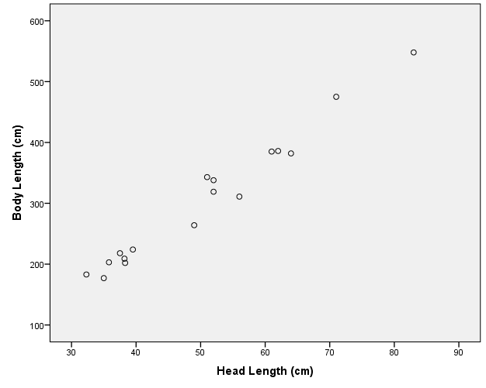

This scatterplot can be made by using SPSS command Graphs – Legacy Dialogs – Scatter/Dot. Click on Define. Then move the Head length or explanatory variable into the box labeled X-axis and the Body length or the response variable into the box labeled Y-axis. Click on OK.

  - The error term $ϵ$ is normally distributed – Yes. Made a QQ plot of the residuals and the points are close to linear.

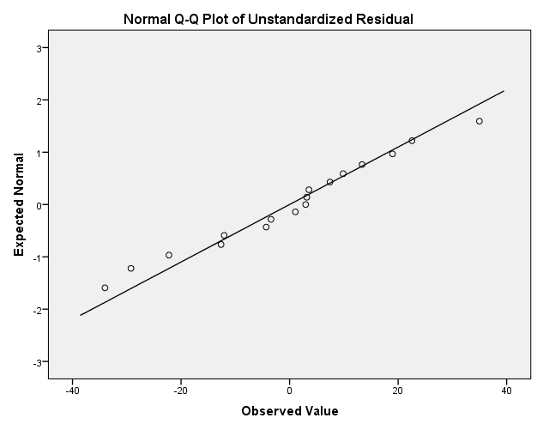

First in SPSS we need to find the residuals. This is done by performing the following commands, Analyze – Regression – Linear. Then move the Body length or the dependent variable in to the “Dependent” box, and move the Head length or the independent variable into the “independents” box. Then click on Save and mark the check box for “Unstandardized Residuals”. Click on Continue and then OK. When these commands are executed there will be a new column in your SPSS data file labeled RES_1. Next a QQ plot of the residuals can be made by performing the following SPSS commands, Analyze – Descriptive Statistics – Explore. Now just move the variable Unstandardized Residuals into the dependents box. Click on Plots and make sure the Normality Plots with Test box is check marked. Then click on OK.
  - The variance of the error terms is constant for all values of X – Yes there is no megaphone shape in the residual plot.
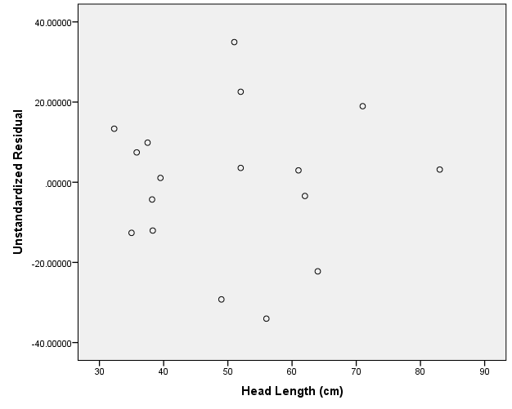
To make a residual plot in SPSS do the following: Graphs – Legacy Dialogs – Scatter/Dot. The click on Define. Move the variable representing the Residuals to the Y-axis box, and mover your independent variable or in this case head length into the X-axis box. Click on OK.
  - X’s are fixed and measured without error. (In other words, the X’s can be considered as known constants.) We will assume that X’s have been measured accurately and precisely.
  - The observations are independent. – We will assume that the Y’s are independent.

- Test if there is a linear relationship between Head Length and Body Length.

  - State the null and alternative hypotheses.

$$H_{o}: β_{1}=0$$
$$H_{a}: β_{1}≠0$$

  - Let alpha = .05

  - State the test static and value of test statistic

It is a t-test statistic t = 22.675

This test statistic is found in the SPSS output by using the commands Analyze – Regression – Linear. Then doing as we have done before and moving the head length into the independents box and the body length into the dependent box. The test statistic and P-value are given in the following output.

Coefficientsª
Model |  | Unstandardized Coefficients |  | Standardized Coefficients | t | Sig. | 95.0% Confidence Interval for B
 |  | B | Std. Error | Beta | t | Sig. | Lower Bound | Upper Bound
1 | (Constant) | -69.369 | 17.083 |  | -4.061 | .001 | -105.780 | -32.959
1 | Head Length (cm) | 7.400 | .326 | .986 | 22.675 | .000 | 6.704 | 8.096
a. Dependent Variable: Body Length (cm)
Test Statistic P-value CI

  - Based on the P-value, do you reject or fail to reject the null.

P-value = 0.000000000000508 < 0.05 Therefore we reject the null.

  - State your conclusion.

We have sufficient evidence to suggest that there is a linear relationship between the head length and the body length of the Gharial crocodiles.

- Create a 95% confidence interval for the true slope of the regression line relating Head Length and Body Length.
The 95% confidence interval for the true slope of the regression line is (6.704, 8.096)
When performing the command Analyze – Regression – Linear, make sure to click on Statistics and check the 95% confidence interval box, so that it can be calculated as well.

